Constraints on the Use of Three-Dimensional Models for the Simulation of Dynamic Freshwater Lenses

F. Ghassemiª and K.W.H. Howard^{b}
ª Centre for Resource and Environmental Studies, The Australian National University, Canberra ACT 0200, Australia (user@server)
^{b} Groundwater Research Group, University of Toronto, Ontario, Canada (user@server)

Abstract: Freshwater lenses are the major sources of water supply in many atoll islands in the Pacific and Indian oceans, particularly in dry seasons. Presently, numerous two- and three-dimensional mathematical models are available for the simulation of atoll island aquifers. The two-dimensional models such as the powerful SUTRA are unable to represent the three dimensional distribution of various parameters, the boundary conditions of the problem, and adequately simulate pumping wells. These limitations may be overcome by using a three-dimensional model, however, this will be a very challenging task. To demonstrate the related problems, an attempt was made to simulate the case of Home Island in the Indian Ocean. This exercise demonstrated that such modelling required a very fine three-dimensional discretisation of the island and short time steps of a few hours, in order to overcome the numerical instability. This required a very significantly large CPU time, even on the most sophisticated workstations. Obviously, this problem can be overcome by running the model on a super computer. However, the main problem is due to the paucity of knowledge of various parameters involved. While the Home Island dataset is comprehensive, the quality and quantity of the available data proved inadequate to meet calibration needs.
Keywords: Groundwater; Atoll islands; Freshwater lens; Modelling.

- INTRODUCTION
Freshwater lenses are the major sources of water supply in many atoll islands in the Pacific and Indian oceans, particularly in dry seasons. In most atolls a transition zone of variable density separates the freshwater lens from the saline seawater, while in the others, transition from freshwater to saline seawater can be represented by a sharp interface. Development of the atolls' limited freshwater resources is seriously constrained by the presence of brackish and saline seawater at shallow depths. Therefore, groundwater extraction by pumping methods will cause upconing of the brackish and saline seawater and will reduce the quality of the pumped water. To prevent this problem, extraction via horizontal galleries laid at shallow depths are recommended. However, an accurate estimation of the sustainable extraction rate of the lens and its sensitivity to reduced recharge during the drought periods requires application of advanced modelling techniques.
This paper describes relevant studies of the Home Island freshwater lens in the Indian Ocean as a case study. Alam and Falkland [1998] used the two-dimensional model SUTRA [Voss, 1984] to revise the sustainable yield estimate for the Home Island freshwater lens. Simultaneously, an attempt was made to develop a three-dimensional numerical model of the Island. Ghassemi et al. [1999] describe preliminary results of this modelling.

2. NUMERICAL MODELLING OF FRESHWATER LENSE
2. 1 Introduction
During the past few decades, a large volume of literature has been published dealing with various aspects of hydrogeology and salinity in atoll island aquifer systems and its numerical modelling.
Currently, several density dependent solute transport models suitable for the simulation of atoll

island aquifer systems are commercially available. These include SUTRA [Voss, 1984], which is a two-dimensional model, while HST3D [Kipp, 1997], and SALTFLOW [Molson and Frind, 1994] are examples of three-dimensional models. These models provide solutions of two simultaneous, non-linear partial differential equations that describe the conservation of mass of fluid and conservation of mass of solute in porous media.

  - Calibration of a Freshwater Lens Model

Numerical models of freshwater lenses should be adequately calibrated in the following cases in order to be reliable for simulation of various management options:
- Calibration of the model in steady state.
- Calibration of tidal transmission.
- Transient calibration over a relatively long period of time.

3. HOME ISLAND
Home Island is situated in the Indian Ocean, approximately 2800 km northwest of Perth (Western Australia). It is a low-lying island with elevation of 1 to 3 m above mean sea level. It has an average annual rainfall of 1950 mm.
The island consists of a dual aquifer system. The upper unconsolidated coral sediments of Holocene age overlay unconformably the Pleistocene hard coral limestone. The depth to unconformity ranges from 9.6 m to more than 17 m below ground surface.
The measured values of hydraulic conductivity at the depths of 3 to 12 m ranged from 1.6 to 26 m d ⁻¹, while below 12 m, they ranged between 20 and 650 m d⁻¹.
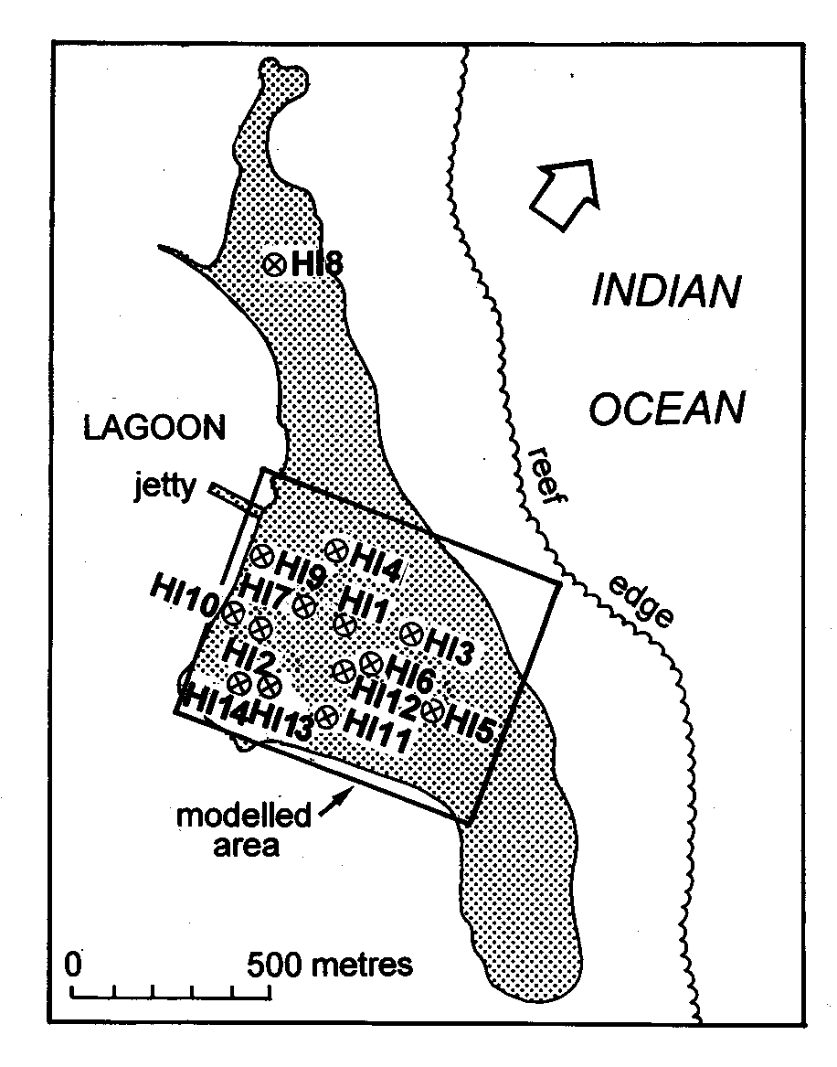
Figure 1. Location of monitoring boreholes in Home Island.
In order to explore the hydrogeology of the Island, 9 boreholes (HI1 to HI9) were drilled in 1987 to depths ranging from about 12 m to 21 m and a multi-level water sampling system was installed in each borehole (Figure 1). In 1990, four boreholes (HI9 to HI12 with HI9 relocated) and in 1996 two additional boreholes (HI13 and HI14) were drilled and equipped with multi-level water sampling systems. Although the monitoring system was designed to provide reliable point measurements of groundwater electrical conductivity (EC), values indicate some anomalies. For example, Figure 2 shows that the measured EC values at the depths of 5 and 8 m below mean sea level (BMSL) are almost identical.
The Home Island water supply is based on groundwater extracted from the freshwater lens (Figure 3) with supplementary rainwater collected from roofs. Total average pumping from the freshwater lens increased from about 100-115 m³ d⁻¹ in the period 1983-1988 to higher values of 223 and 194 m³ d⁻¹ in 1996 and 1997.
Figure 2. Plots of the measured electrical conductivity (EC) at the monitoring borehole HI11.
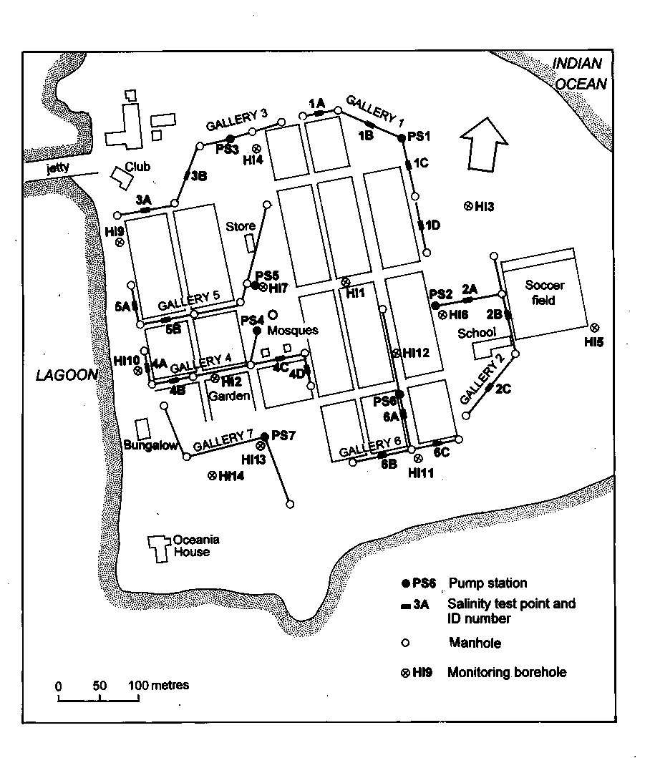
Figure 3. Home Island infiltration gallery and observation boreholes.

Further detailed information regarding geography, climate, hydrogeology, salinity monitoring systems, recharge estimate, water supply and estimation of the sustainable yield of the Home Island freshwater lens is available in Ghassemi et al. [1999].

4. NUMERICAL SIMULATION OF THE HOME ISLAND AQUIFER
4.1 Model Description
The three dimensional simulation of the Home Island aquifer system described in this paper is based on the application of the SALTFLOW model [Molson and Frind, 1994]. A brief description of the model is provided in the following paragraphs.
SALTFLOW is a numerical model for solving complex density-dependent groundwater flow and mass transport problems. The model can be used to solve one, two, or three-dimensional mass transport problems within a variety of hydrogeological systems.
Finite elements are employed for high accuracy and to allow deformable domain geometry. The model includes an efficient preconditioned conjugate gradient solver to solve the matrix equations. In this model the equation of conservation of mass of fluid is expressed as:
$$\frac{¶}{¶x_{i}}\left[K_{\text{ij}}\left(\frac{\text{¶y}}{¶x_{j}}+gc{\bar{n}}_{j}\right)\right]−\sum_{k=1}^{N}{Q_{k}}(t)⋅d(x_{k},y_{k},z_{k})=S_{s}\frac{\text{¶y}}{¶t}(1)$$
where $x_{i}$ are the 3D spatial coordinates $(x_{i} = x,y,z), t$ is time (T), $K_{\text{ij}}$ is the hydraulic conductivity tensor (L T⁻¹) and $y$ is the equivalent freshwater head (L). The constant $g$is defined by $g=\left({ρ_{\text{max}}}/{ρ_{o}}−1\right)\text{where}ρ_{\text{max}}$ (ML⁻³) is the maximum fluid density and $ρ_{o}$ (ML⁻³) is the reference freshwater density, $c$ is the relative concentration, ${\bar{n}}_{j}$ is the unit vector, $Q_{k}(t)$ is the volume flux (L³T⁻¹) for the sources/sinks located at $(x_{k}, y_{k},z_{k}), N$ is the number of sources/sinks, $δ$ $(x_{k}, y_{k}, z_{k})$ is the Dirac delta function (L⁻³) and $S_{s}$ is the specific storage coefficient (L⁻¹).
The equation of conservation of mass of salt is represented by:
$$\frac{¶}{¶x_{i}}\left[\left(\frac{D_{\text{ij}}}{R}\right)\frac{¶c}{¶x_{j}}\right]−\frac{¶}{¶x_{i}}\left(\frac{v_{i}}{R}c\right)−λc+\sum_{k=1}^{N}{}\frac{Q_{k}(t)c_{k}(t)}{Rq}⋅d(x_{k},y_{k},z_{k})=\frac{¶c}{¶t}(2)$$
where $D_{\text{ij}}$ is the hydrodynamic dispersion tensor (L² T⁻¹), $v_{i}$ is the average linear groundwater velocity (L T⁻¹), $R$ is the retardation factor (dimensionless), $λ$ is the first order decay term (T⁻¹) and $q$ is the porosity of the saturated media (dimensionless).
Further details regarding the theoretical basis of the SALTFLOW model, spatial and temporal discretisation criteria, and example applications are available in Molson and Frind [1994].

4.2 Discretisation
In the previous 3D-modelling of the Home Island [Ghassemi et al., 1999], the central part of the Island with dimensions of 800 m long, 650 m wide and 30 m deep was simulated for the steady state conditions. In that simulation, following testing of various uniform and variable grids, the aquifer was discretised with a variable spacing grid ranging from 5 m to 12.5 m in the horizontal and from 1 m to 2 m in the vertical direction. This discretisation generated 90,090 (77 x 65 x 18) nodes and 82,688 (76 x 64 x 17) elements. In the current modelling, the aquifer was simulated to the depth of 50 m for the same area. In order to reduce the numerical errors, a finer grid with variable spacing ranging from 2.5 m to 12.5 m in the horizontal and from 1 m to 10 m in the vertical direction was used (Figure 4).

Figure 4. Horizontal and vertical discretisation of the Home Island.

This discretisation increased the number of nodes to 148,410 (97 x 85 x 18) and the number of elements to 137,088 (96 x 84 x 17), about 65 percent more than the previous case. It should be noted that in both cases, unconformity between the unconsolidated Holocene sediments and the Pleistocene coral limestone was simulated at the depth of 12 m below MSL.

4.3 Boundary Conditions
Flow boundary conditions consist of: a flux boundary due to recharge from rainfall at the top surface; a no-flow boundary at the bottom surface (at the depth of 50 m); and fixed heads of 0 m along the four lateral sides. SALTFLOW converts these heads to their equivalent freshwater heads in depth, considering a density of 1.0245 kg per litre for seawater. Solute boundary conditions consist of: zero concentration for the rainwater recharging the aquifer from the top; zero concentration gradient at the bottom; and fixed concentration of 1.0 (relative to seawater) on the four lateral sides from MSL to the depth of 50 m, except for the nodes at MSL where a relative concentration of 0.3 was considered.

4.4 Stresses
The aquifer system is affected by various natural and human-induced stresses. Major natural stresses are tidal forces and variable recharge due to climatic variations, while human-induced stresses are due to extractions from wells or infiltration galleries installed at a depth of less than 1 m below MSL.

4.5 Steady State Calibration
The year 1987 was considered for the steady state calibration of the model and for preparation of the initial condition for transient calibration. For this year (1987) extraction rates from 5 shallow wells were: 27.4 m³ d⁻¹ (PS1); 21.6 m³ d⁻¹ (PS2); 27.4 m³ d⁻¹ (PS3); 23.0 m³ d⁻¹ (PS4); and 17.3 m³ d⁻¹ (PS5). Therefore, the total extraction rate was about 117 m³ d⁻¹. In terms of recharge, an average annual value of 855 mm was used.
The computations were performed on a Sun Ultra 2 Workstation Model 2300. In terms of computation time, each run of the model required approximately 50 hours CPU time to simulate a period of 1500 days with time steps of half a day. The SALTFLOW code was compiled with the Fujitsu FORTRAN 90 compiler that accelerated the computations by a factor of 2.5 compared with the FORTRAN 77 compiler.
Table 1. Parameter values used to describe the Home Island aquifer system and their comparison with published values: (a) Alam and Falkland [1998]; and (b) Underwood et al. [1992].
Parameters and their units | Calibrated values | (a) | (b)
Porosity | 0.25 | 0.20 | 0.25
Holocene sediments thickness (m) | 12 | 12 | 15
Holocene sediments horizontal hydraulic conductivity (m d⁻¹) | 15 | 10 | 50
Holocene sediments vertical hydraulic conductivity (m d⁻¹) | 15 | 5 | 10
Pleistocene sediments horizontal hydraulic conductivity (m d⁻¹) | 1500 | 1000 | 500
Pleistocene sediments vertical hydraulic conductivity (m d⁻¹) | 300 | 200 | 100
Longitudinal dispersivity (m) | 4 | 10 | 6-12
Transverse dispersivity (m) | 1 | 0.5 | 0.01
Vertical dispersivity (m) | 0.05 | 0.05 | 0.01-0.05
Average annual recharge (mm) | 855 | 855 | 500-2000

Model parameters were estimated by trial and error using limited measurements taken on the island and values adopted by Underwood et al. [1992] for their generalised atoll island model simulated with SUTRA [Voss, 1984]. The parameter values resulting from model calibration are listed in Table 1.
In order to check the degree of match between the computed and the measured salinities, their values have been compared at all monitoring boreholes operating in 1987. Results indicate that the computed salinities are not free from numerical instabilities. Discrepancies between the measured and computed salinities are due to: lack of knowledge about model parameters and their three dimensional distributions; differences between the real and simulated boundaries of the aquifer; and the fact that the aquifer system is not in a steady state equilibrium.

4.6 Simulation of Tidal Wave Transmission
The model was set-up for simulation of tidal wave transmission in the aquifer system by using the parameters provided in Table 1 and a sinusoidal tidal wave with amplitude of 0.8 m consisting of two high peaks and two throughs in every 24 hours. The model was run with time steps of about 36 minutes. Results of simulations indicated that tidal efficiencies were approximately 24 percent, which are close to the measured values for sites PS1 to PS4. It should be noted that simulation of tidal waves with lower hydraulic conductivity values of Underwood et al. [1992] produced low tidal efficiencies of about 10 percent.

4.7 Transient Simulation
The model was run over a ten-year period (1988-1997) using quarterly recharge and pumping data. Extractions via shallow wells with short galleries were simulated at pumping sites and neighbouring nodes from 1988 to 1991. Pumping was extended to include gallery nodes when they were converted to galleries in 1991. Extraction rates for each gallery were distributed over the nodes representing the gallery, and proportional to the effective area of each node, at the depth of 0 m to 1 m. The quarterly recharge rates were uniformly distributed over the nodes at the top layer of the model. For this simulation the parameters shown in Table 1 were used. The computed salinities were compared with the measured values at all boreholes (except HI8) at 3 different depths to obtain a good assessment of the quality of the computed values. The results showed that the model reflects changes in computed salinity values due to changes in pumping rates and recharge. However, there was a clear discrepancy between the measured and the computed values (compare Figures 2 and 5). For this simulation, the size of the input file was about 6300 lines, while it was approximately 200 lines in the steady state simulation. Moreover, the computation time was about 150 hours or 6.25 days for 14,600 time steps of 6 hours (10 years x 365 day x 4).

To improve the computed values, the model was run with monthly values of recharge and pumping data. For this simulation run, the size of input file increased to about 19,000 lines, which is three times longer than the previous case. The computation time remained almost the same (150 hours) for the same 10-year period because the number of time steps remained unchanged. The computed values (Figure 6) show some improvement compared to the previous run with quarterly data. However, they failed to match the measured values at similar locations and depths. Despite numerous runs with modified values of the hydraulic conductivity, porosity and other parameters, no further improvement in the overall distribution of the computed salinity values could be achieved.
Figure 5. Results of transient simulation with quarterly recharge and pumping data at borehole HI11 for three different depths.

5. CONCLUSIONS
Figure 6. Results of transient simulation with monthly recharge and pumping data at borehole HI11 for three different depths.

Recently, significant progress has been made towards the development and application of 3D density-dependent solute transport models. While the development of powerful workstations has facilitated this task, the Home Island modelling exercise using SALTFLOW demonstrated that even the most advanced workstations will be challenged by the 3D simulation of a relatively small atoll island aquifer system with consideration of all parameters and processes affecting the system including tidal forces.
In the Home Island modelling exercise, high computational demand was an unwelcome difficulty, but it was not the reason why calibration could not be achieved. The Home Island modelling exercise failed because the quantity and quality of the available data were simply inadequate to meet calibration needs. Important lessons can and should be learnt. From a practical standpoint this type of modelling exercise should not be contemplated without outstandingly good spatial and temporal datasets and first class computing facilities. It also raises the concern that our ability to develop computer codes capable of simulating complex aquifer systems is exceeding our ability to supply the input data necessary for their reliable calibration.

ACKNOWLEDGEMENTS
The authors wish to thank Tony Falkland and Khairul Alam (from ECOWISE Environmental, Canberra, Australia) for their kind collaboration and providing us with all available data.

REFERENCES
Alam, K., and A.C. Falkland, Home Island groundwater modelling Stage 2, ECOWISE Environmental, Canberra, 1998.
Ghassemi. F., J.W. Molson, A. Falkland and K. Alam, Three-dimensional simulation of the Home Island freshwater lens: preliminary results, Environmental Modelling & Software, 14(2-3), 181-190, 1999.
Kipp, K.L., Guide to the revised heat and solute transport simulator: HST3D-Version 2, Water-Resources Investigations Report 97-4157, US Geological Survey, Denver, Colorado, 1997.
Molson, J.W., and E.O. Frind, SALTFLOW: Density dependent flow and mass transport model in three dimensions, User Guide, Waterloo Centre for Groundwater Research, University of Waterloo, Ontario, 1994.
Underwood, M.R., F.L. Peterson, and C.I. Voss, Groundwater lens dynamics of atoll islands, Water Resources Research, 28(11), 2889-2902, 1992.
Voss, C.I., SUTRA: A finite-element simulation model for saturated-unsaturated fluid density-dependent groundwater flow and solute transport, US Geological Survey, Water Resources Investigation Report 84-4369, 1984.

